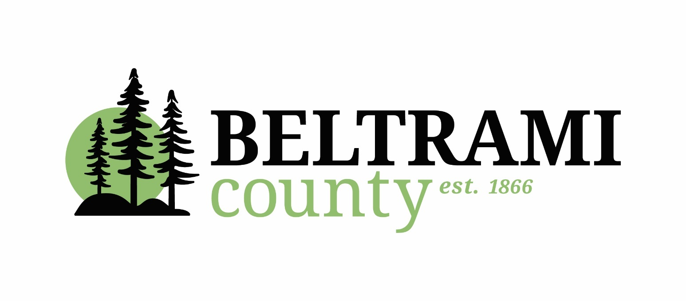

# **Development Fund Grants**

# **Fiscal Year Beginning January 1, 2025**

**INVITATION TO APPLY**

**Applications Due: 4:30 p.m. on Friday, February 21, 2025**

Note: Only electronic applications will be accepted

## **INVITATION TO APPLY**

The Beltrami County Board of Commissioners is accepting applications for grants from the County Development Fund. The County Development Fund is used to distribute revenue received by the County from the management of tax-forfeited land. State Statute sets the limits for the distribution formula and directs that funding must be used for activities that meet the definition for the promotion of tourism, agriculture and industrial development in the county. For Fiscal Year 2025, the total available amount of grant funding to be distributed amongst all applicants will be $45,000.

## **GRANT SUBMITTAL**

Organizations applying for a Development Fund Grant must be located in Beltrami County and be recognized as a not-for-profit organization (i.e. governmental agency, association, public authority, non-profit or civic association). A complete Application Form, with supporting documentation, must be received electronically by the Beltrami County Administrator **by no later than 4:30 p.m. on February 21, 2025.** Late or incomplete applications may not be considered.

**APPLICATIONS AVAILABLE ON-LINE – IN A WORD or PDF FORMAT**

The application may be found on the County website [www.co.beltrami.mn.us](http://www.co.beltrami.mn.us) on the County Administration page: <https://www.co.beltrami.mn.us/departments/administration/> . It is available as a word document that may be edited or as a pdf to print, fill out, and scan for e-mailing.

**GRANT REVIEW**

Complete grant applications will be reviewed by the Beltrami County Board of Commissioners. The ultimate decision on the level of funding, or which requests receive funding, will be a discretionary decision that rests with the Beltrami County Board of Commissioners. The decisions for grant awards have traditionally been made within 6 weeks of the application deadline.

## **GRANT REQUIREMENTS**

The Beltrami County Board has established the following Development Fund grant requirements. These requirements and restrictions have been affirmed during each subsequent grant cycle.

* Funding requests must be used for specific activities that meet the definition for the promotion of tourism, agriculture and industrial development in the County;
* County grants should not be the ‘sole” source of funding for the funding request. The County Board expects a significant funding “match” from the applying organization and/or other identified funding sources;
* Grant applicants are expected to demonstrate a financial commitment and financial contribution from private commercial, industrial, or tourism businesses who could be considered beneficiaries of the program, activity or organization;
* Grant applicants are expected to demonstrate a financial commitment and financial contribution from other local government entities who could be considered beneficiaries of the program, activity or organization;
* The use of County grant proceeds should benefit the entire County or be fairly divided throughout Beltrami County;
* Grant applicants must have no expectation of multi-year funding;
* Grant funds may not be used for normal and routine operating and administrative expenses, including salary, wage and benefit costs.

**QUESTIONS**

Questions or concerns related to the Development Fund grant program

should be directed to:

Tom Barry

Beltrami County Administrator

701 Minnesota Avenue NW, Suite 200

Bemidji, MN 56601-3178

Phone: (218) 333-4109

e-mail: [tom.barry@co.beltrami.mn.us](mailto:tom.barry@co.beltrami.mn.us)

**Please Note:** All information must be sent via e-mail. Organizations that do not receive an e-mail notification can look on the County Website for the Development Fund Application and letter.

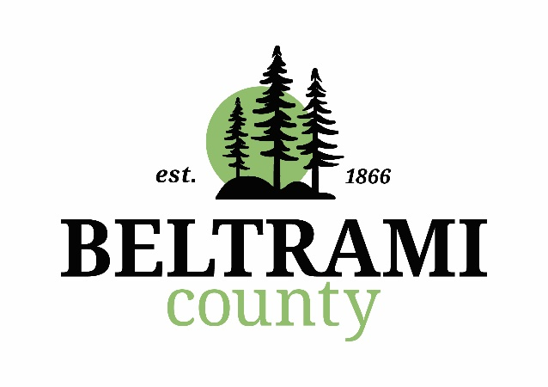**BELTRAMI COUNTY**

# **Development Fund Grants**

**Fiscal Year Beginning January 1, 2025**

# **APPLICATION FORM**

### GENERAL INFORMATION

|  |
| --- |
| Title of Activity or Project: |
| Anticipated Total Cost of Activity: |
| Amount of County Grant Funds Requested: |
| Name of Applicant Organization: |
| Organization Web Page Address: |
| Address: |
| Contact Person: |
| Telephone #: |
| Fax #: |
| e-mail address: |
|  |
| Describe the operation and history of applicant organization: |
|  |
|  |
|  |
|  |
|  |
|  |
|  |
|  |
|  |
|  |
|  |
|  |
|  |

# USE OF GRANT FUNDS

|  |
| --- |
| 1. Describe the specific activity to which the grant funding would be applied and how the activity will promote tourism, agriculture and industrial development in the county: |
|  |
|  |
|  |
|  |
|  |
|  |
|  |
|  |
| 2. Describe the expected outcomes from the proposed tourism, agriculture or industrial development activity and how your organization will measure or evaluate the success of the activity: |
|  |
|  |
|  |
|  |
|  |
|  |
|  |
|  |
| 3. List any organizations with whom you will collaborate or partner in order to complete the activity: |
|  |
|  |
|  |
|  |
|  |
|  |
|  |
|  |
| 4. Describe how the activity will be sustained financially in the future without additional County funding: |
|  |
|  |
|  |
|  |
|  |
|  |
|  |
|  |

# FINANCIAL INFORMATION

# The following documents must be attached to this application:

1. Detailed budget for the host organization – for new organizations only
2. Detailed budget for the proposed activity including all sources and uses of funds;
3. Authorized financial statements from the most recent fiscal year – for new organizations only

I hereby certify that the information included with this application is complete, and is true and correct to the best of my knowledge, and that I have been authorized by the requesting organization to make this declaration and to submit this application on behalf of the stated organization.

Signature: _________________________________________________

Position: __________________________________________________

Organization: ______________________________________________

Date: ______________________________

Note: The contents of this application are considered public information and may be released upon request.